https://docs.google.com/document/d/1bvnxY4f-Z2NOTm2v0FdYhB5hgdfW6G_FqX_-bd_mQ00/edit?tab=t.0

- Postorder Traversal [Easy]
- Asked in [Google, Amazon, Facebook, Adobe]
solution link
- Preorder Traversal [Easy]
- Asked in [Google, Amazon]
solution link
- Level Order Traversal - Coding Ninjas

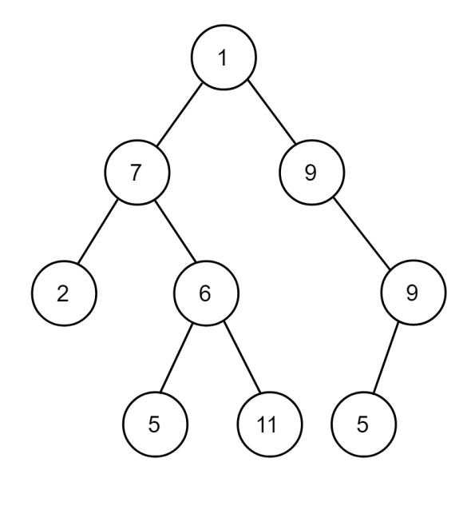

- What should you write in input.txt in order to input this binary tree?
4. Answer:
1 7 9 2 6 -1 9 -1 -1 5 11 5 -1 -1 -1 -1 -1 -1 -1

